**Feature File Data Parameterization**

**Problem Statement:**

There are situations where a large number of data needs to be used for testing, especially in situations like API related testing where testing is primarily data intensive. Updating or adding data to feature file manually is time consuming and error prone.

**Solution:**

An idea to handle this data update with the specific feature file format using a Java based Utility, by providing an easy to edit excel template generated out of the feature file in question. This Utility helps the user to extract the keys needed for a specific feature file in to an excel where the user can easily fill up the data required and upload it back to the feature with the format required , and recreate /replacing a new feature file with updated data

**Steps to use this Tool:**

1. The Data Parameterization is embedded in the Comparator tool.

Double click on the “Comparator Jar” file to open the Utility

1. Navigate to MultiData tab



1. Two tabs “Excel Template Generation” and “Feature File Generation”

**Excel Template Generation:**

1. Click on the “**Browse**” button and Navigate to the path where the Feature file is present and Select

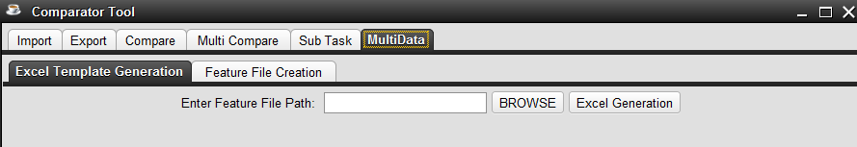

1. After selecting the Feature File, Click on the “**Excel Generation**” Button. An Excel sheet will be generated in the path of the Feature File with the same name as that of the Feature file, having the keys present (Eg: username, password etc..)

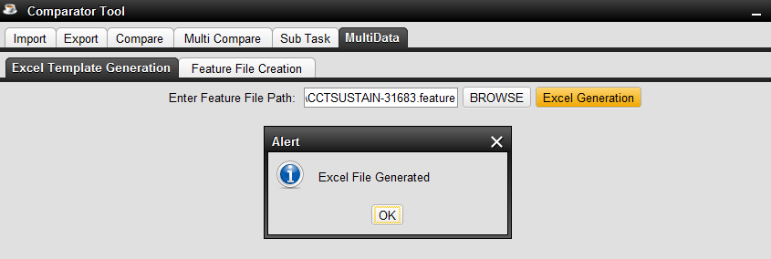

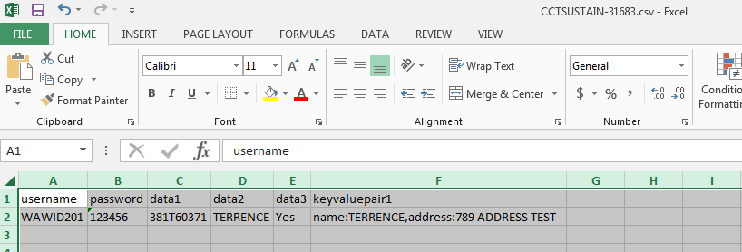

**Excel Sheet Generated Successfully!!!**

**Feature File Generation:**

1. Update the Excel Sheet generated in the previous tab with any number of data’s as required.

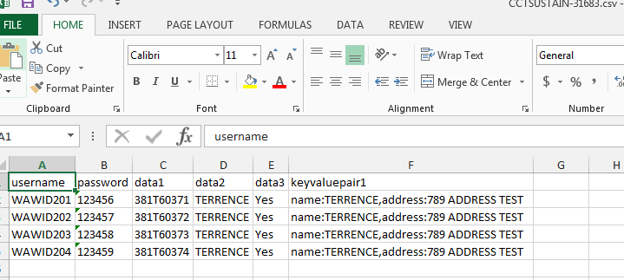

1. Click on the **Feature File Generation** Tab and Select Excel File from which the data has to be mapped and Feature File base to generate a New One with ALL data’s

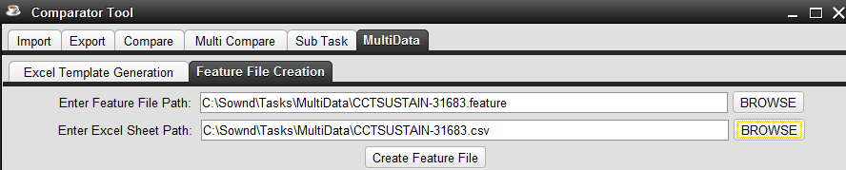

1. Click on **Create feature File,** New Feature File will be generated with new set of data’s in the path mentioned (Eg: CCTSUSTAIN-XXXX_new.feature)

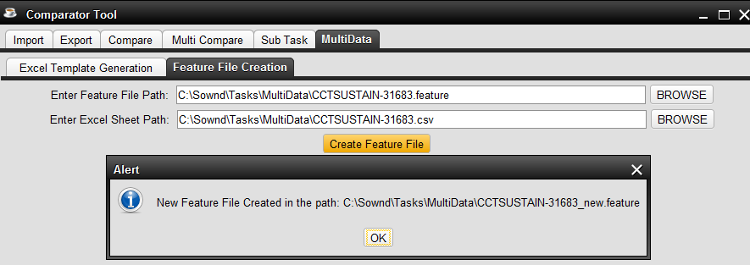

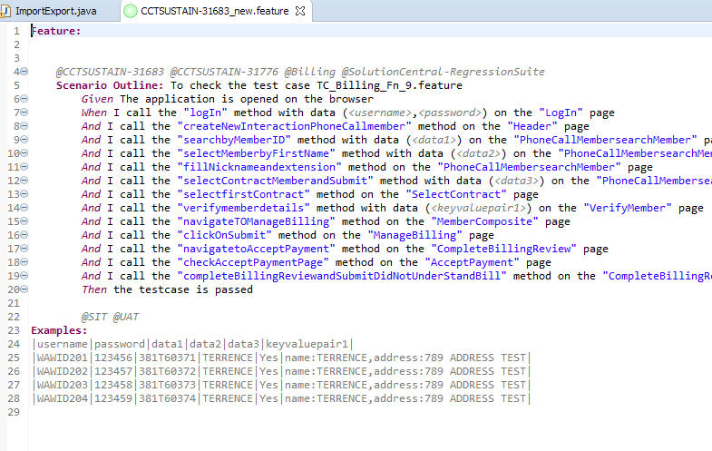

**New Feature File Generated Successfully!!!**